# Run times

Going to use run and time to see where code is getting stuck

## Chaff Parameters

* 18x18 grid chaff
* 8-10 GHz
* Theta = [0,pi/2]
  + 50 values
* Phi = [0, pi/2]
  + 40 values

## Run 01 – no holes

No putting holes. Just what would happen for a base case. As expected, most time spent in changeEinc

Run time was 9.544 seconds.

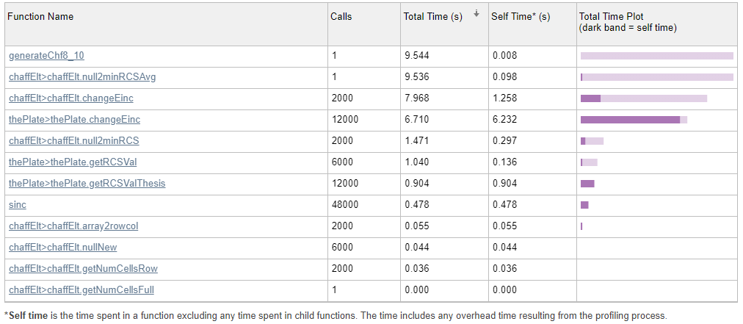

## Run02 – all holes

What happens if I null everything? It gets really slow

Run time 461.447 seconds or 7.69 minutes

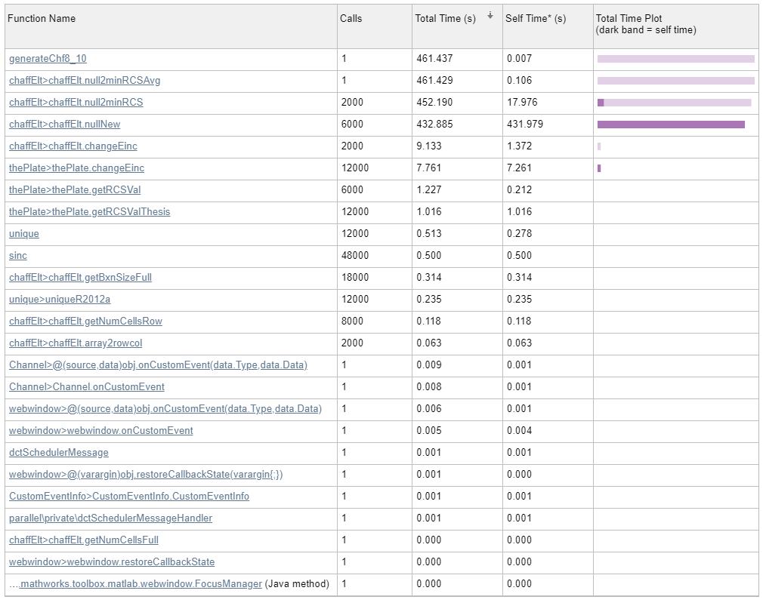

### Things I’m trying to figure out

#### What’s happening in nullNew?

The matrix inversion is getting called 18000 times

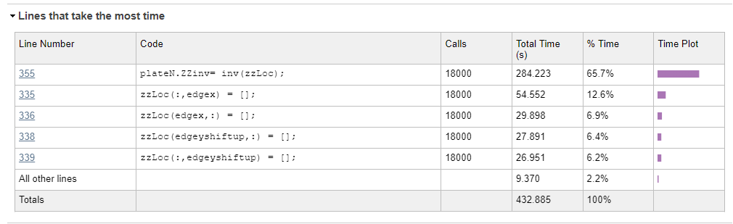

#### Why is stuff getting called so many times?

NullNew gets called 6000 times and inv is getting called 18000 times… why?

Put nullNew in null2minRCS… this gets called for every angle. Of course this is going to be slow… oops

## Run 03 – all holes – fixed for loop problem

nullNew was inside a for loop it shouldn’t have been in… It goes faster now. Now changeEinc is what’s slowing it down. It updates both plates (one with holes and one without)

Run time: 29.153 seconds

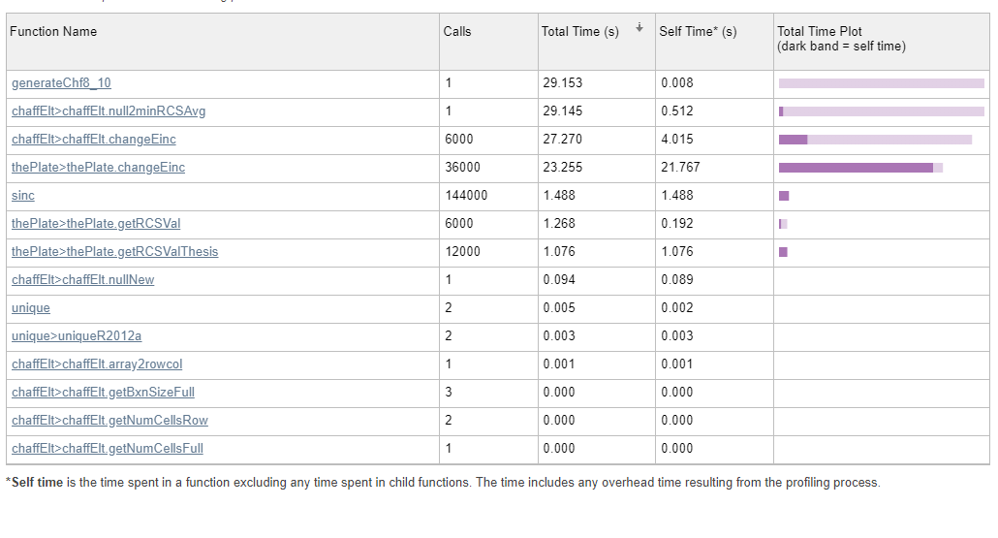

## Run04 – all holes – fixed change Einc

The chaff code store 2 plates one with holes and one without. I thought it was a good idea to have line that updates both at the same to keep them consistent for comparison stuff. It’s slowing code down though, so took that out. It goes fast now

